# Project title : Garage Management System

**DEMO VIDEO : https://drive.google.com/file/d/19sl-jZRR7ZEnaxqxarFzez2eyKR8uhFE/view?usp=drivesdk**

College name : Sree Narayana Guru College

College code : BRU36

Team ID : NM2025TMID26627

Team Leader : Muhammed Nashid

Mail id : muhammadnashid25@gmail.com

# Members

Name : Muhammad rafin

Mail id : mohammadrafin16@gmail.com

Name : Navaneeth Krishna P

Mail id : navaneethkp387@gmail.com

Name : NIDHIN R

Mail id : nidhinjunior117@gmail.com

# Project Overview

The Garage Management System is a software application developed to streamline and digitize the daily operations of an automobile garage. It provides a single platform to manage customer details, appointments, service records, billing, feedback, and reports efficiently.

The system allows garage staff to store and access **customer and vehicle information**, schedule and monitor **service appointments**, record detailed **service reports**, and generate accurate **bills and invoices**. It also includes a **feedback module** to capture customer reviews and a **dashboard with reports** that provide insights such as the number of services completed, revenue generated, and overall customer satisfaction.

By automating manual tasks and centralizing all information, the Garage Management System minimizes errors, saves time, improves customer experience, and enhances overall productivity. It ensures smoother business operations and supports better decision-making for garage management.

# Objectives

1. **To automate garage operations** by replacing manual record-keeping with a digital system.
2. **To maintain accurate customer and vehicle information** in a centralized database for quick access.
3. **To manage appointments efficiently**, allowing customers to book, reschedule, or cancel services easily.
4. **To generate detailed service reports** that track work performed, spare parts used, and costs.
5. **To provide accurate billing and invoicing**, reducing calculation errors and ensuring transparency.
6. **To collect and analyze customer feedback** for improving service quality and customer satisfaction.
7. **To offer dashboards and reports** that provide insights into daily operations, revenue, and performance trends.
8. **To enhance productivity and time management** by reducing paperwork and repetitive manual tasks.
9. **To improve decision-making** for garage management through real-time data and reporting tools.

# Needed Components & Its details

* **Fully active Saleforce account** (new account or existing account)
* **Objects in Saleforce** : Customer Details, Appointment, Service Records, Billing Details And Feedback

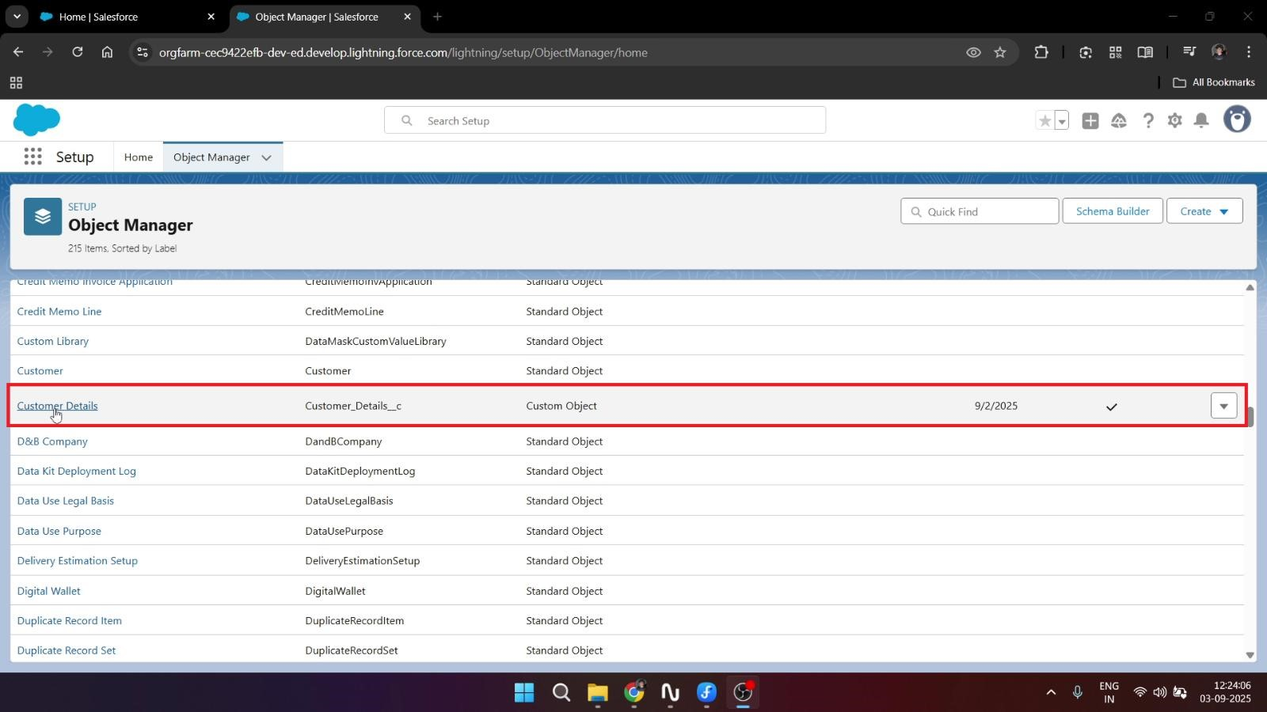

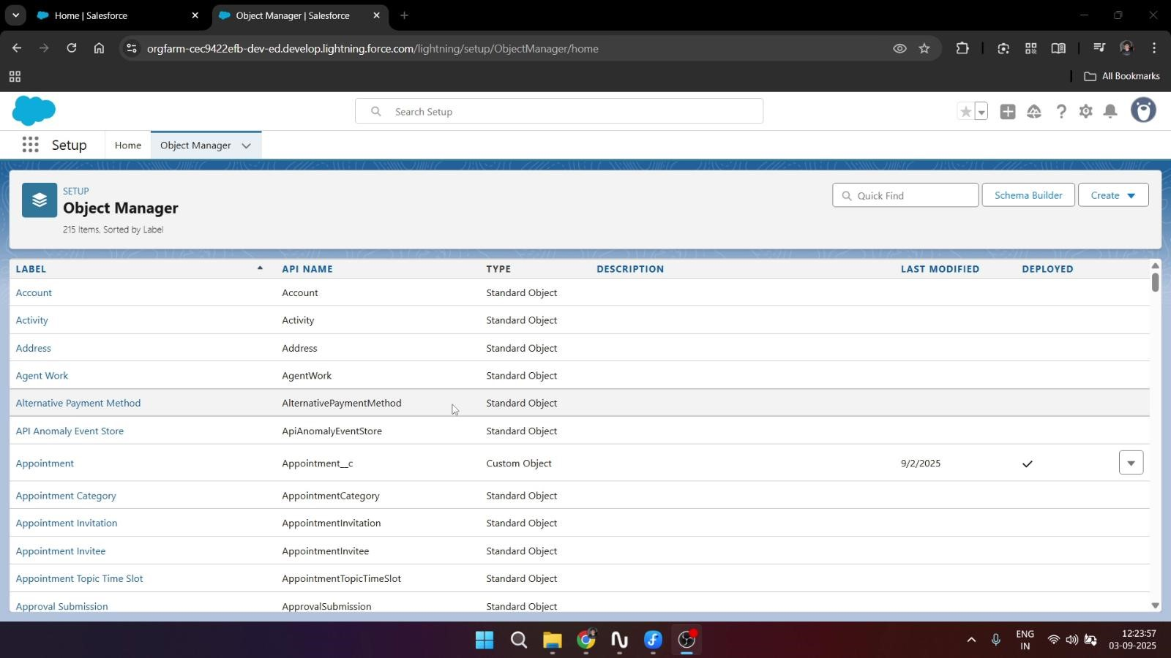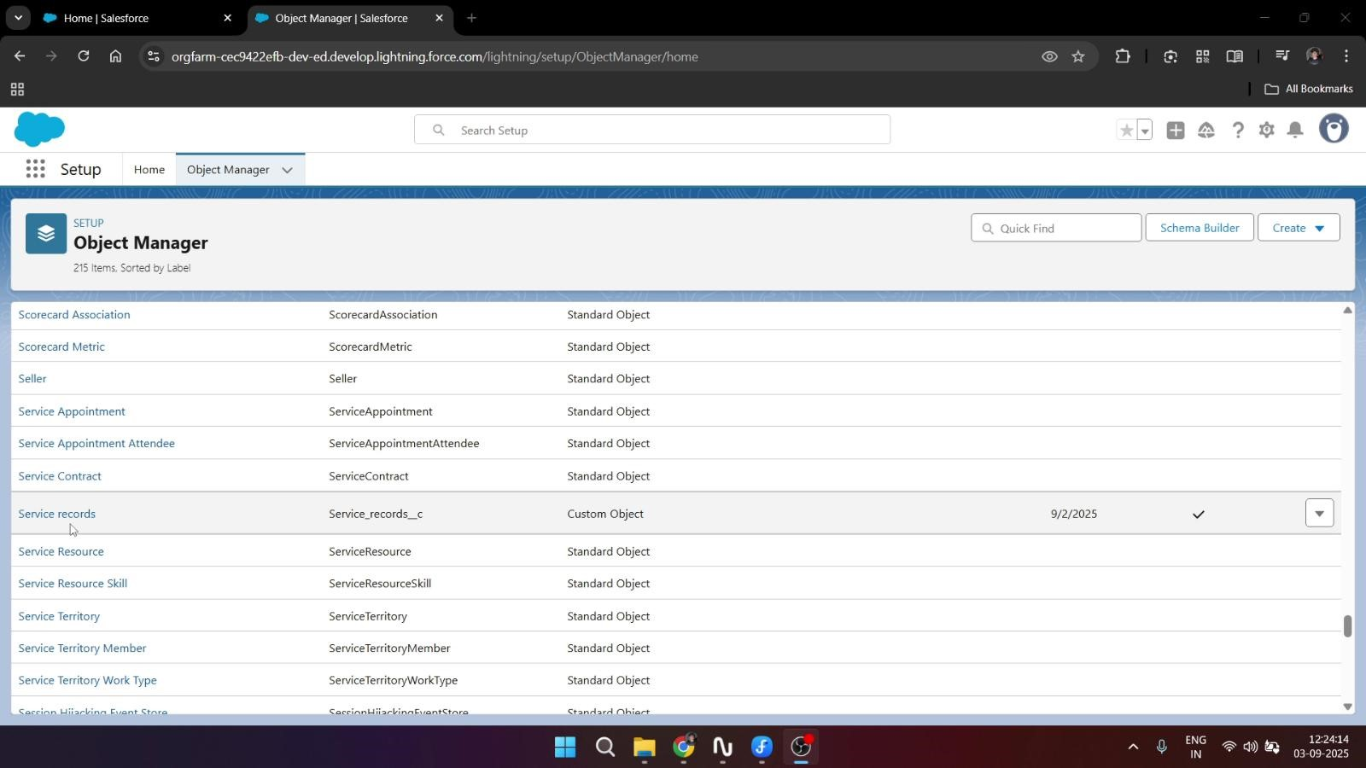

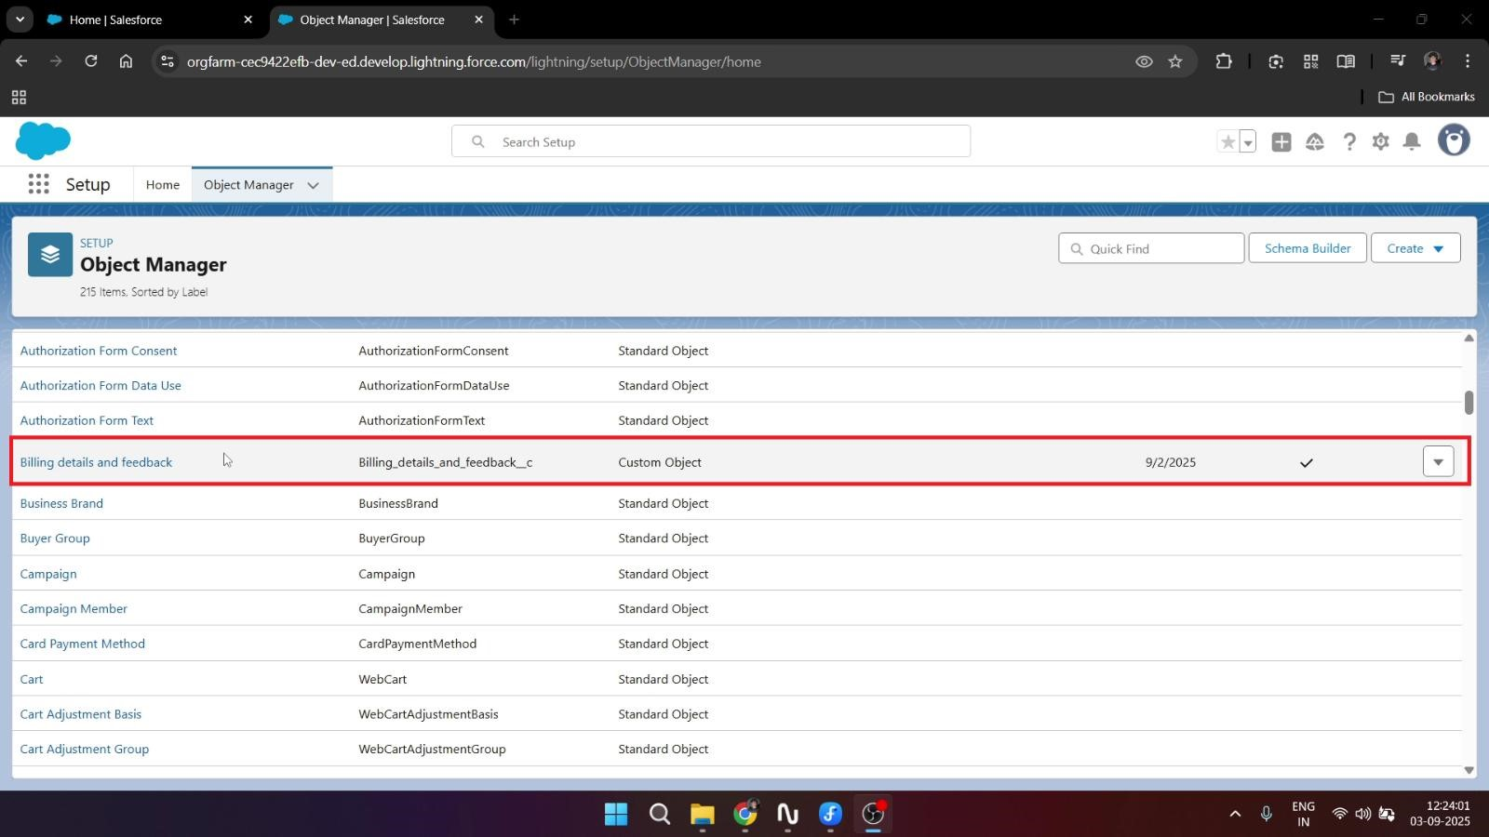

* **Custom tabs**

•

**Lightning app**

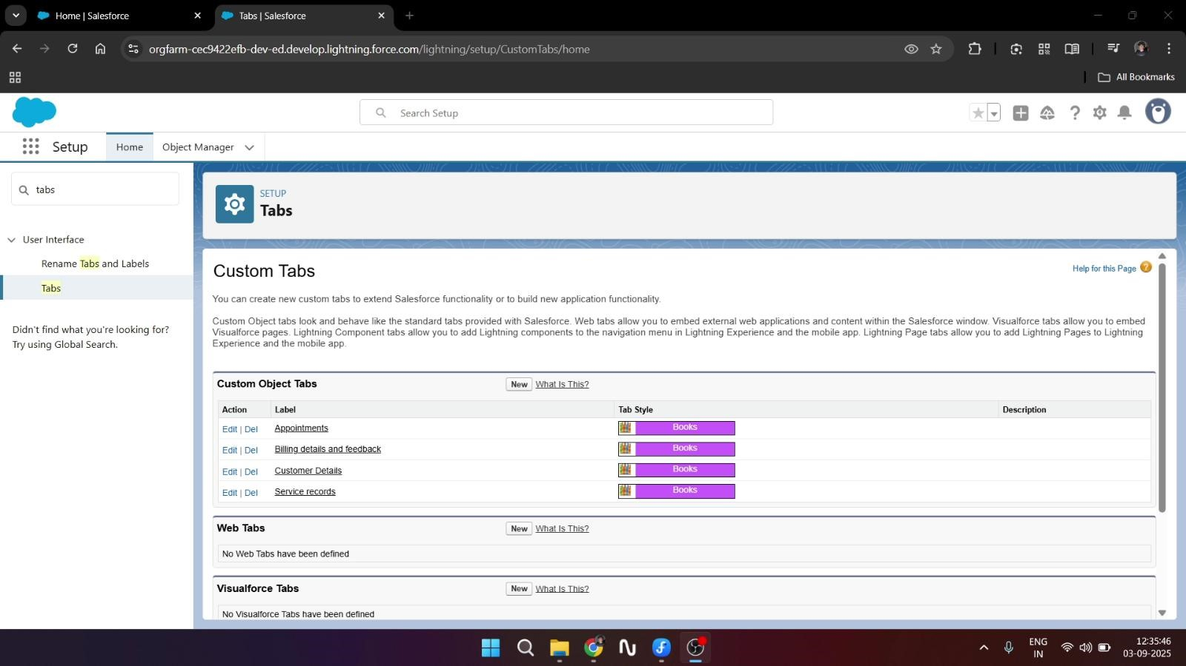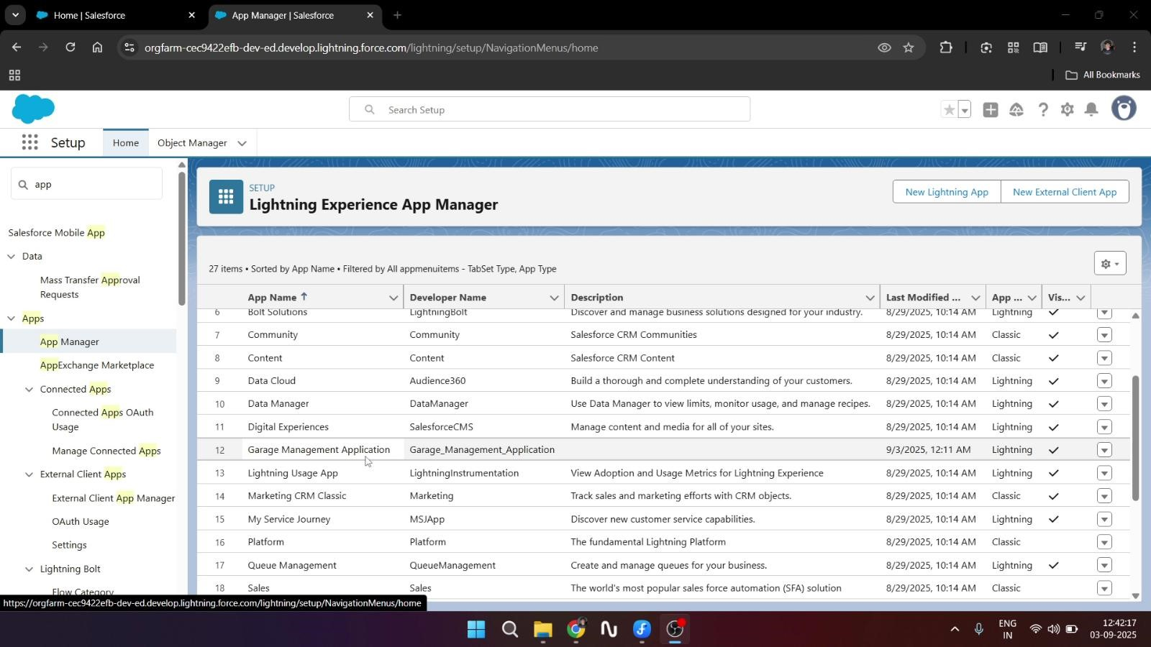

* **Fields and Relationships for created objects**

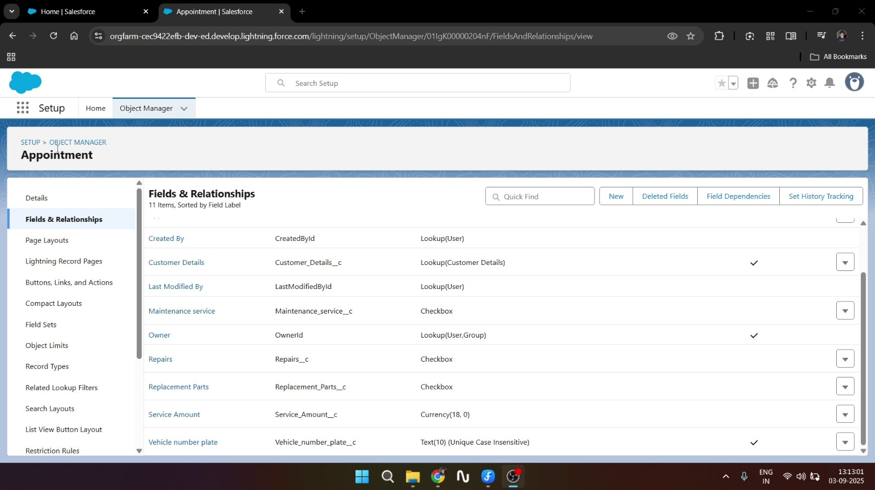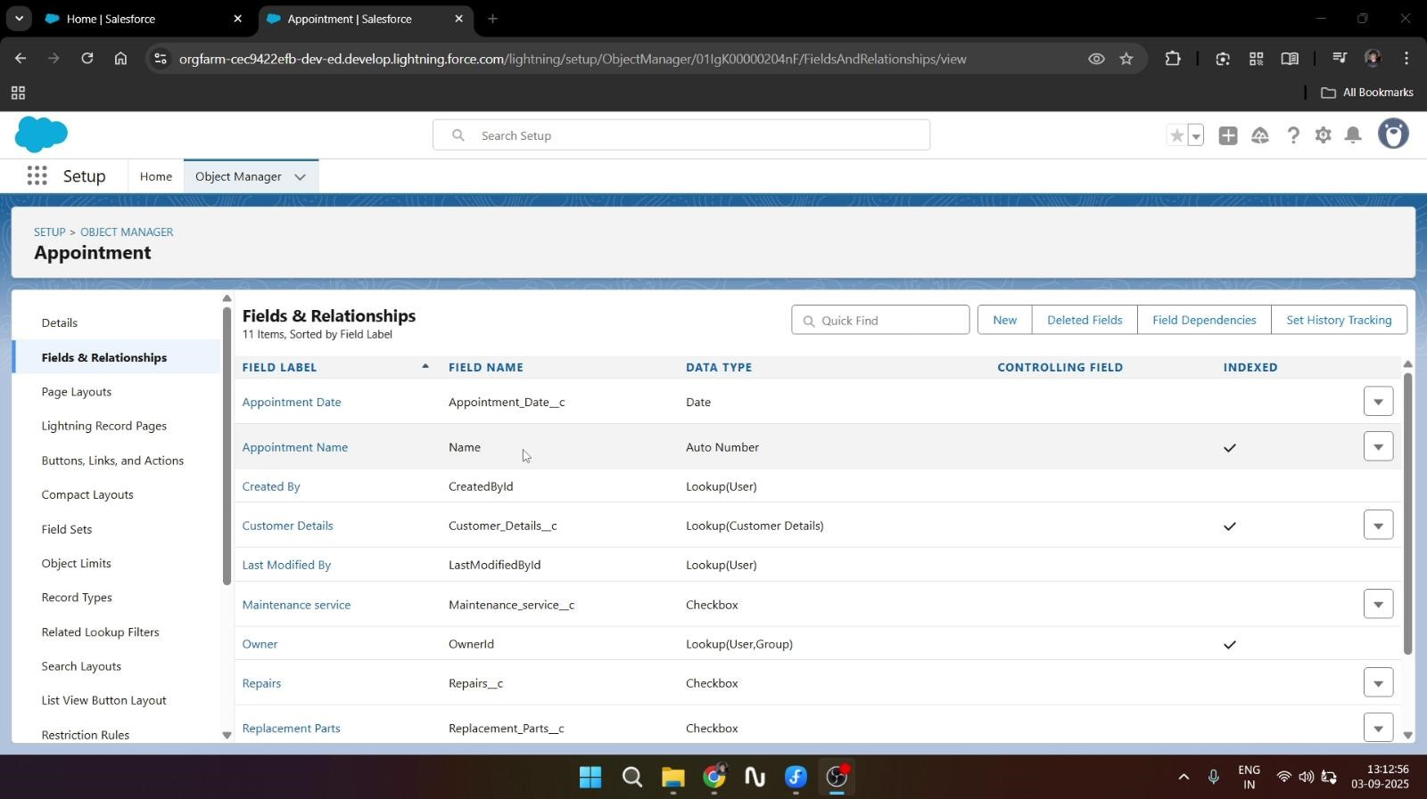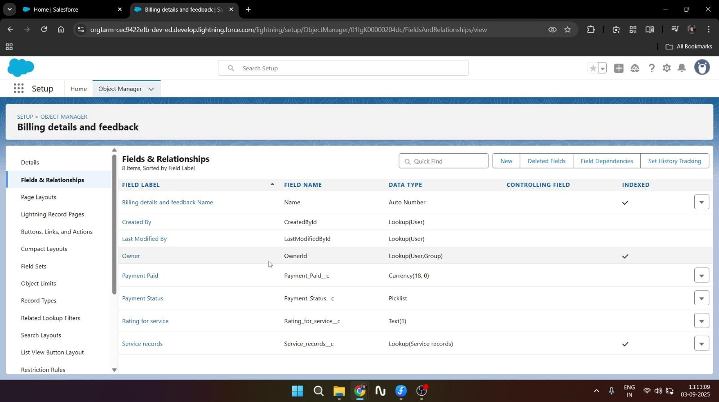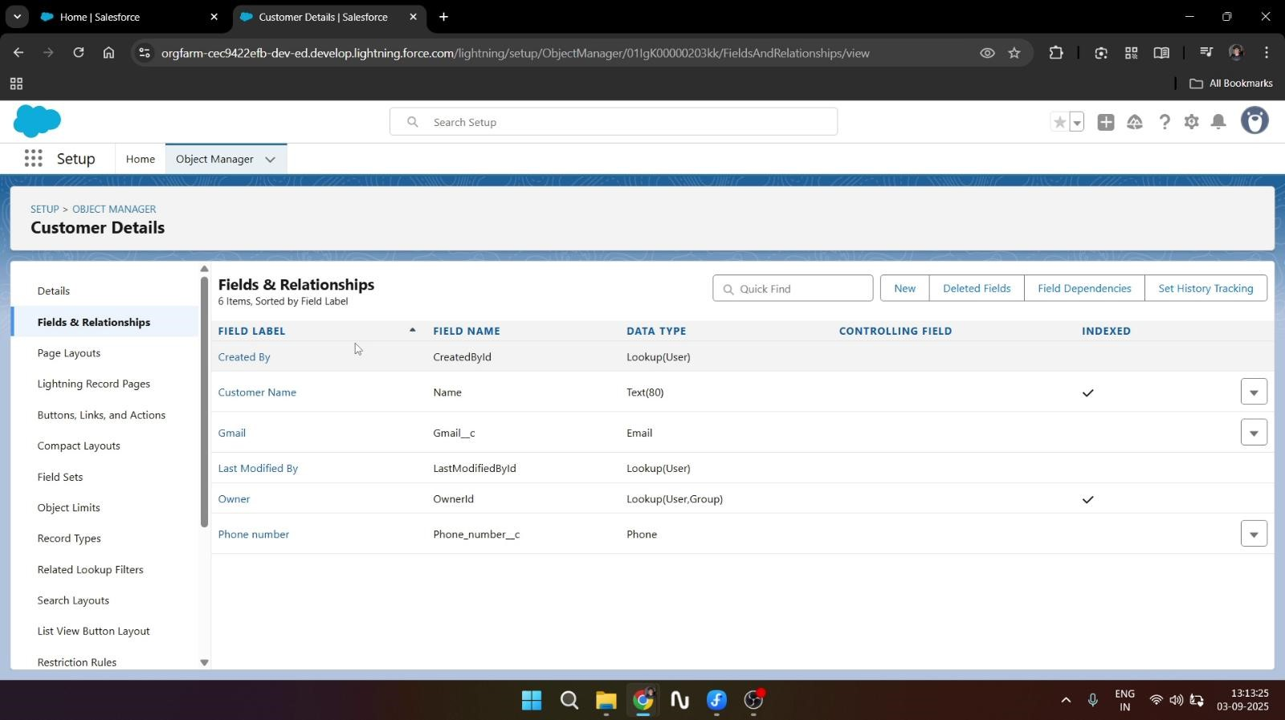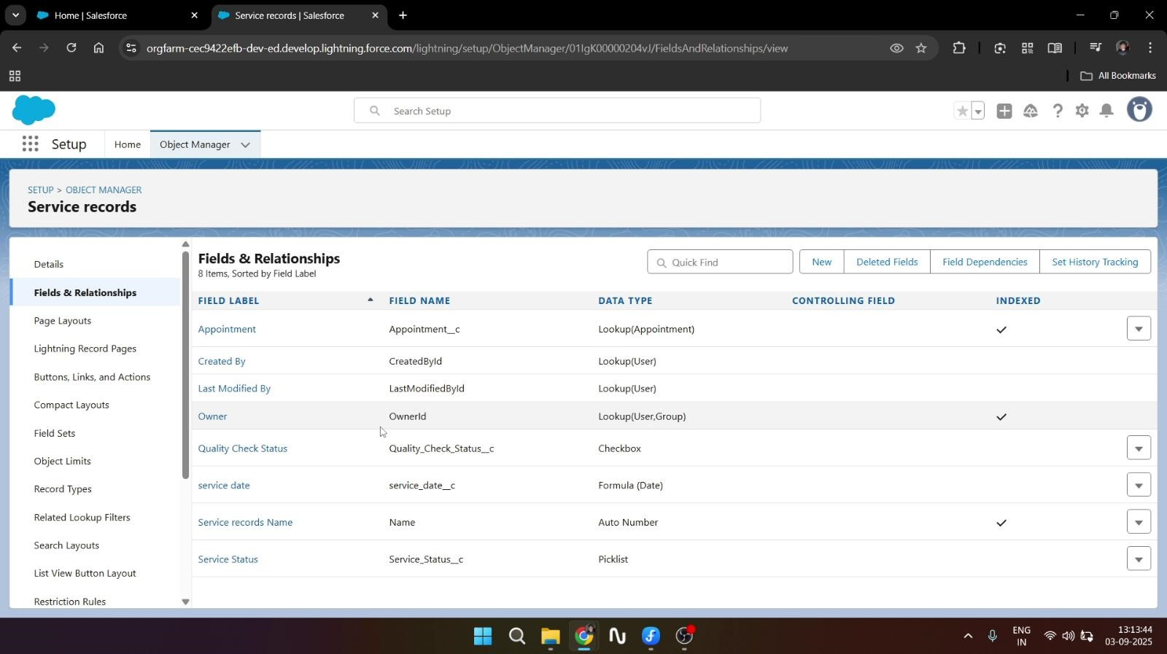

* **Validation Rules**

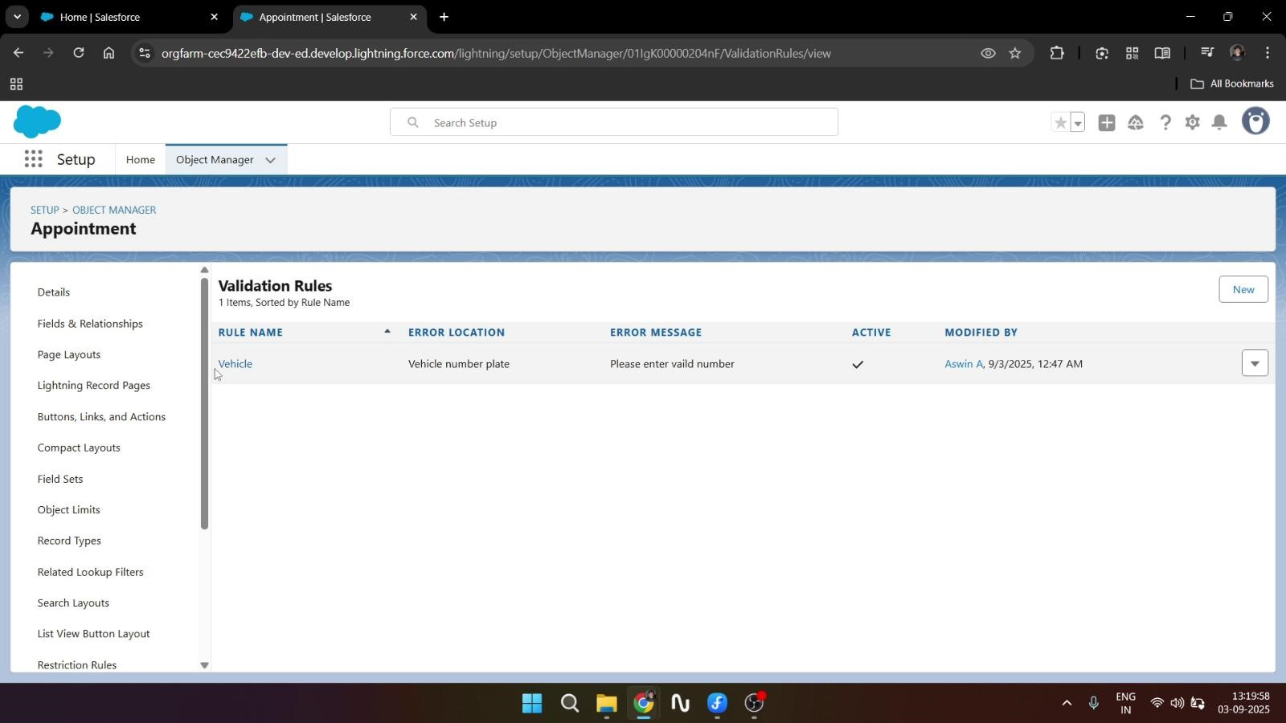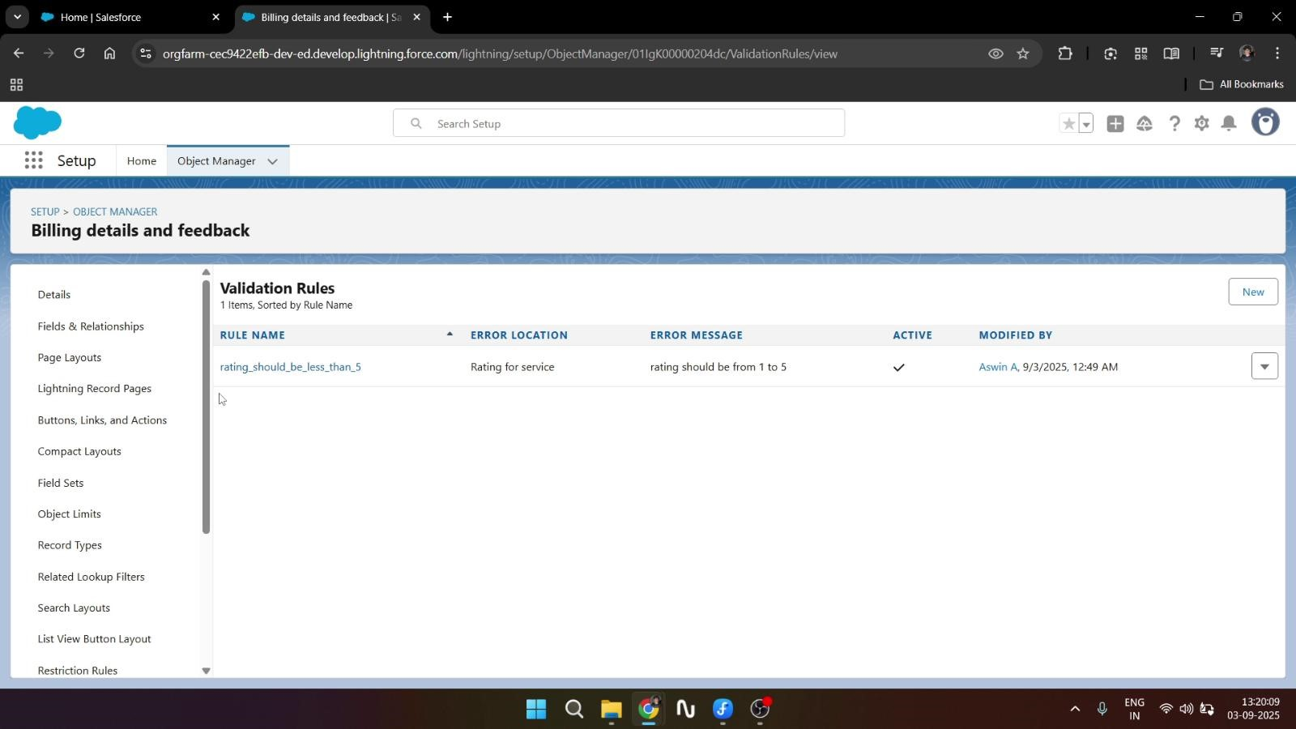

* **Matching &Duplicate Rules**

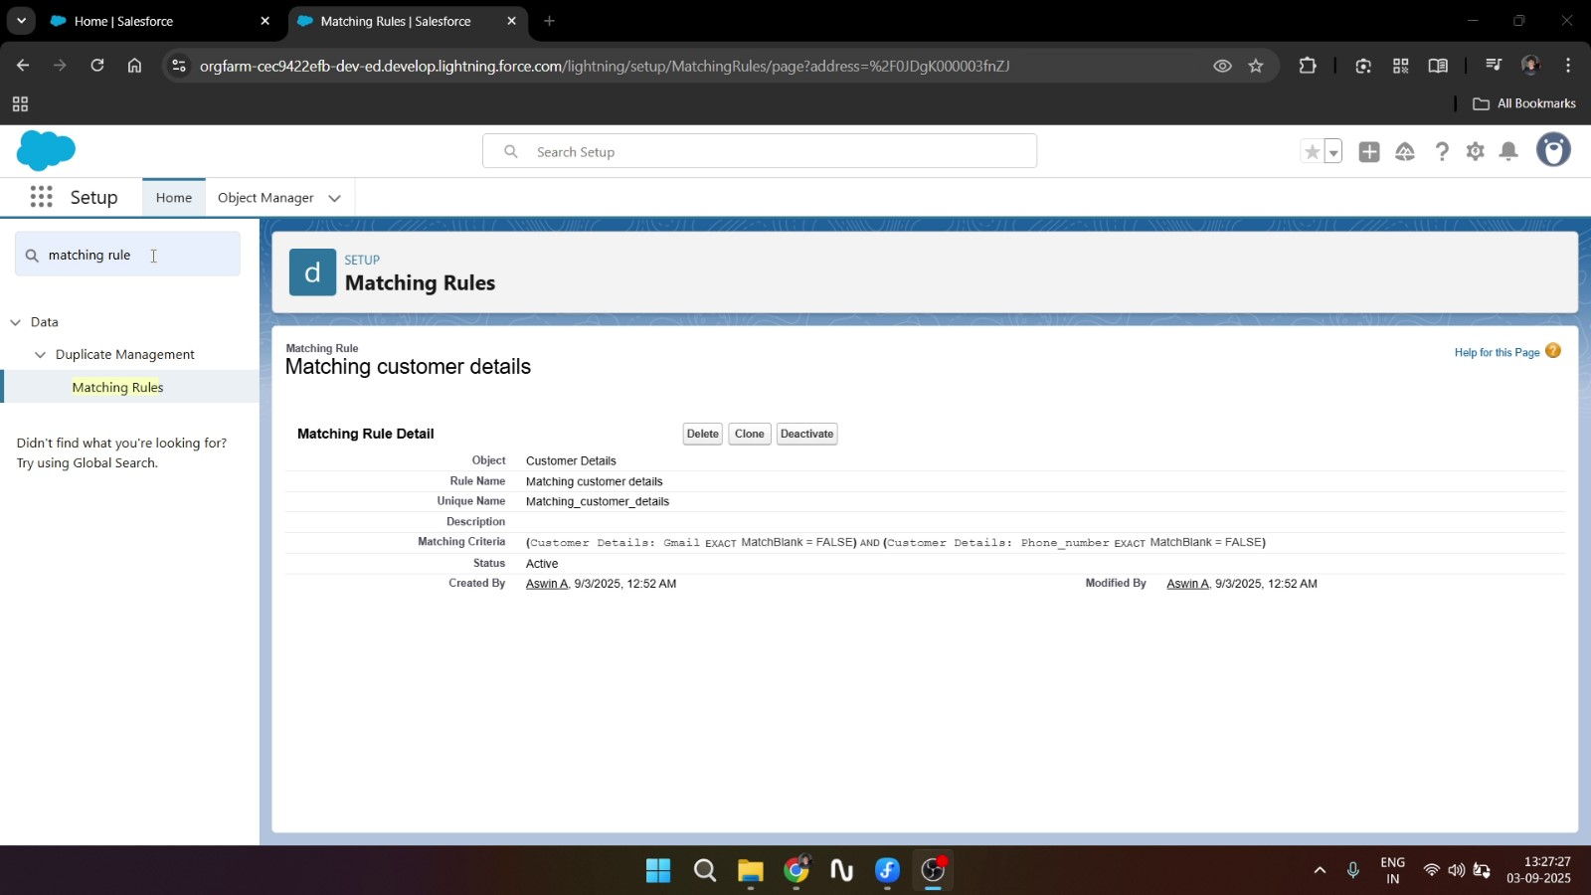

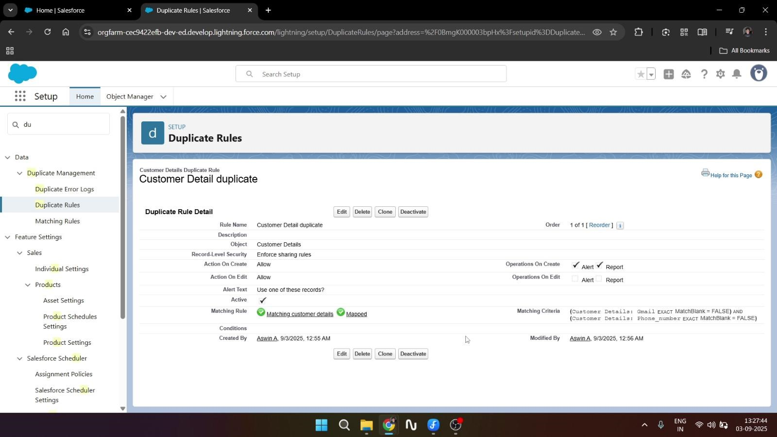

* **Profiles & Its custom object permissions**

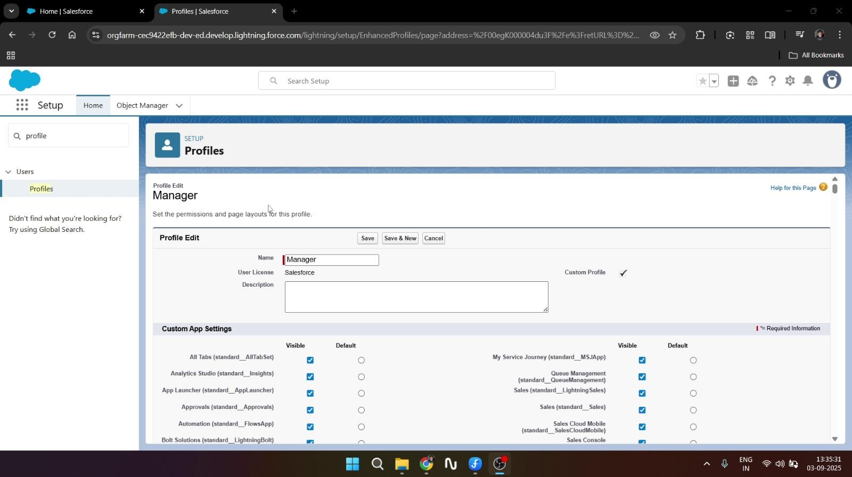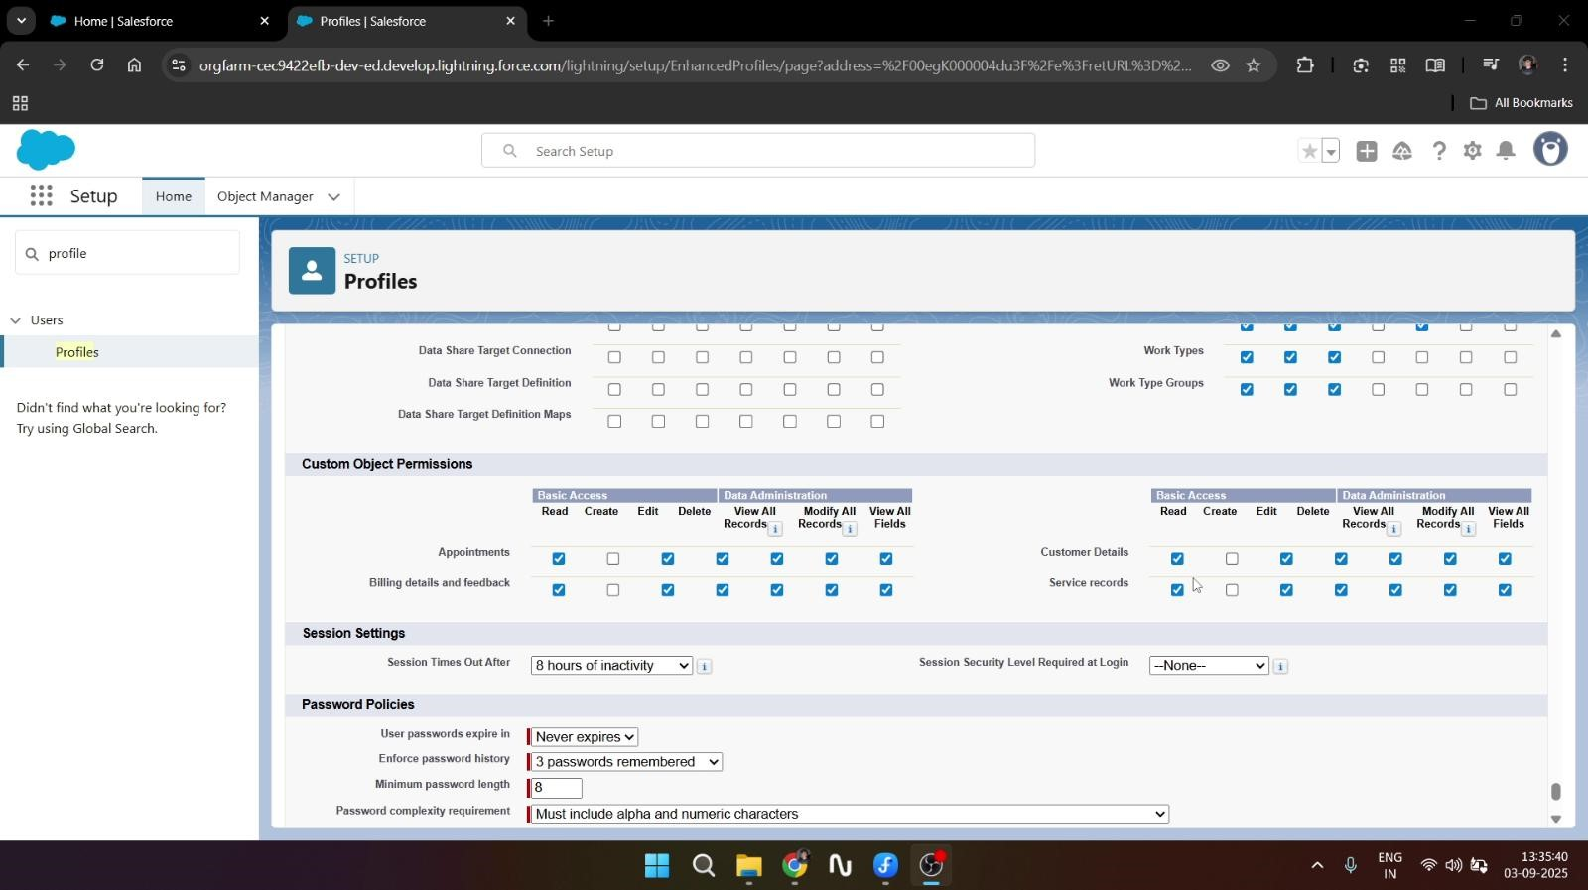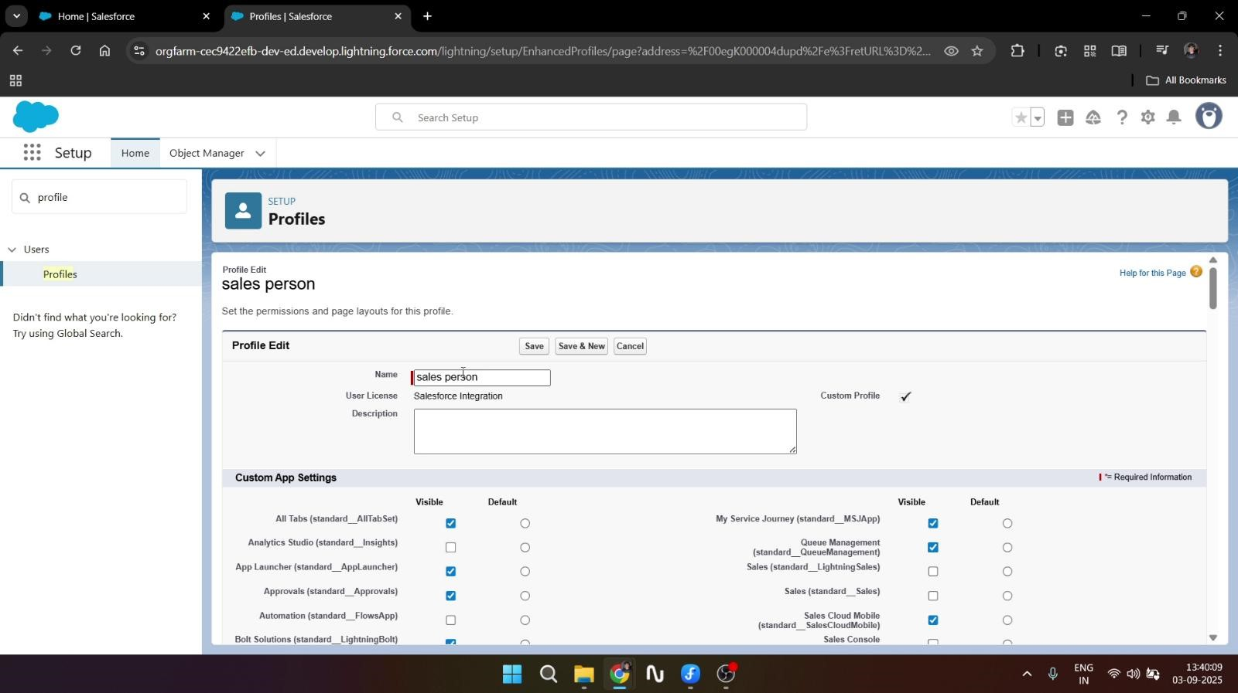

•

**Role & Role Hierarchy**

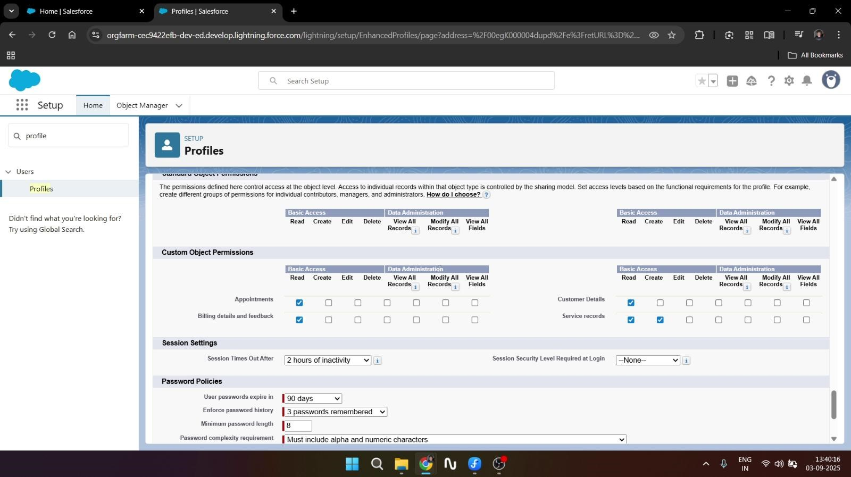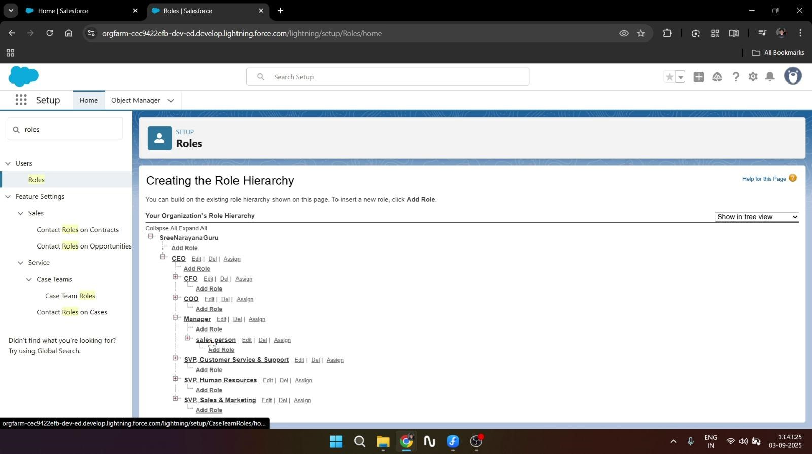

* **Users**

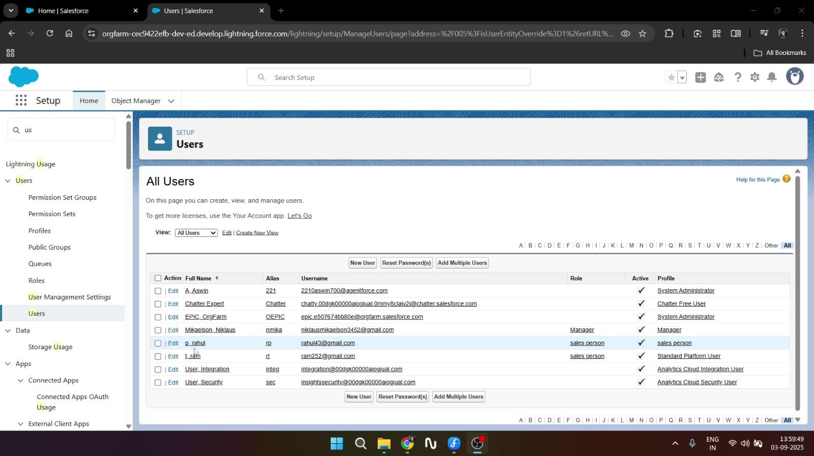

* **Public Group**

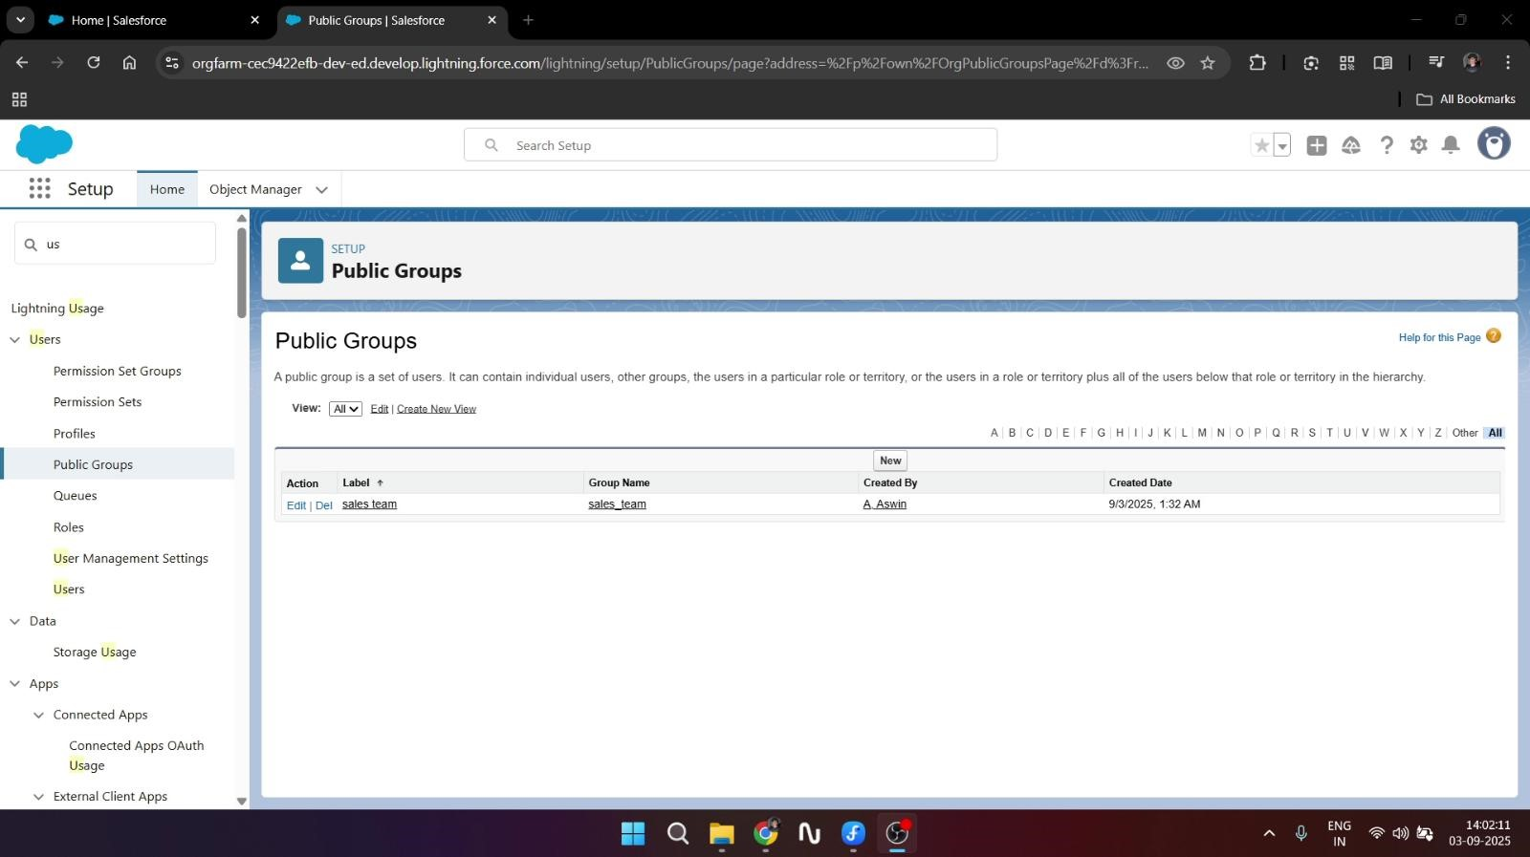

* **Share Setting**

•

**Flows**

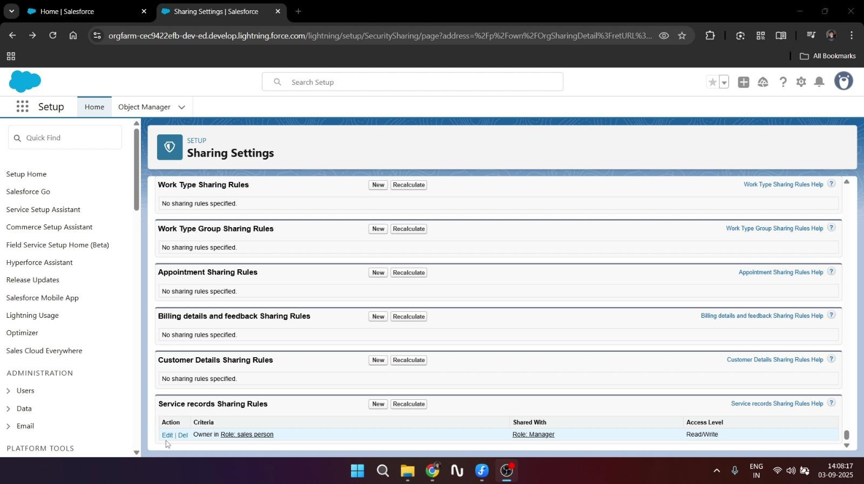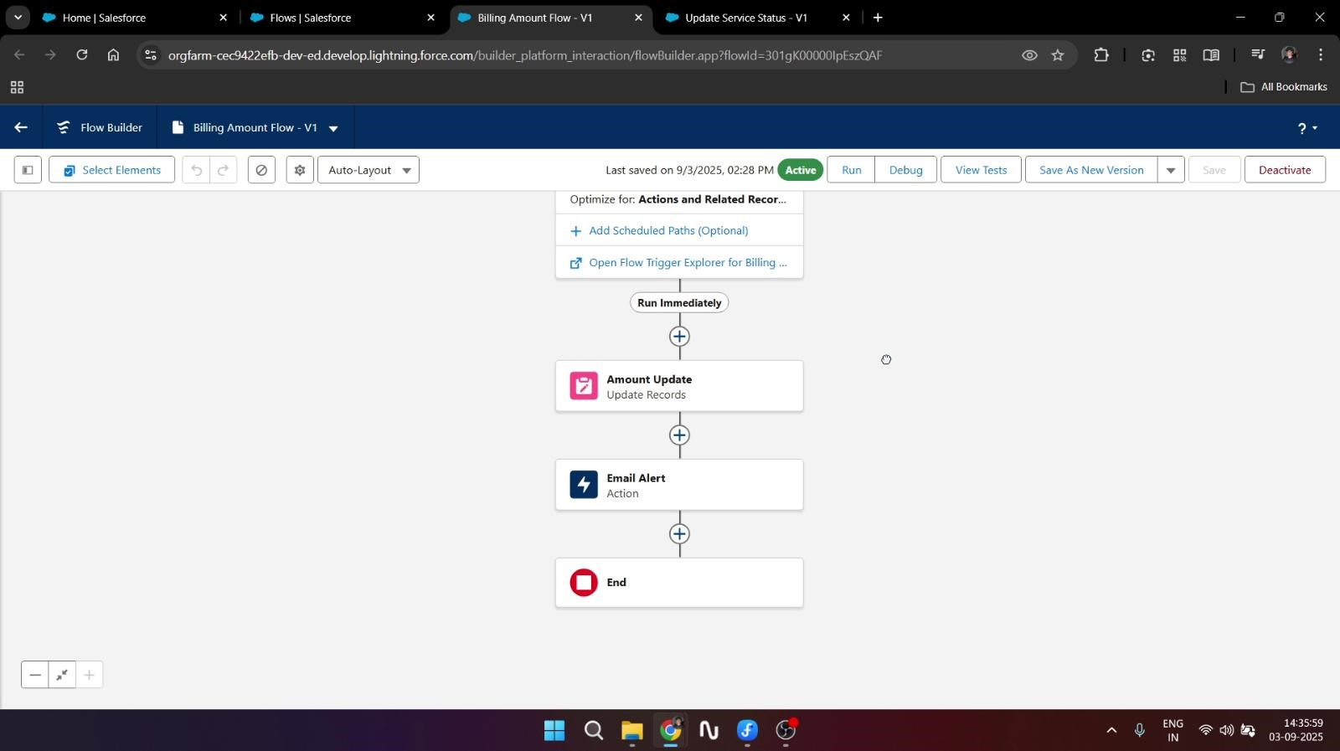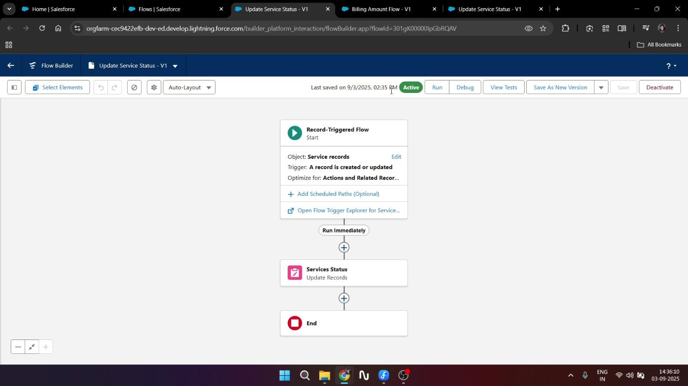

* **Apex Handler** (Apex class & Apex Trigger)

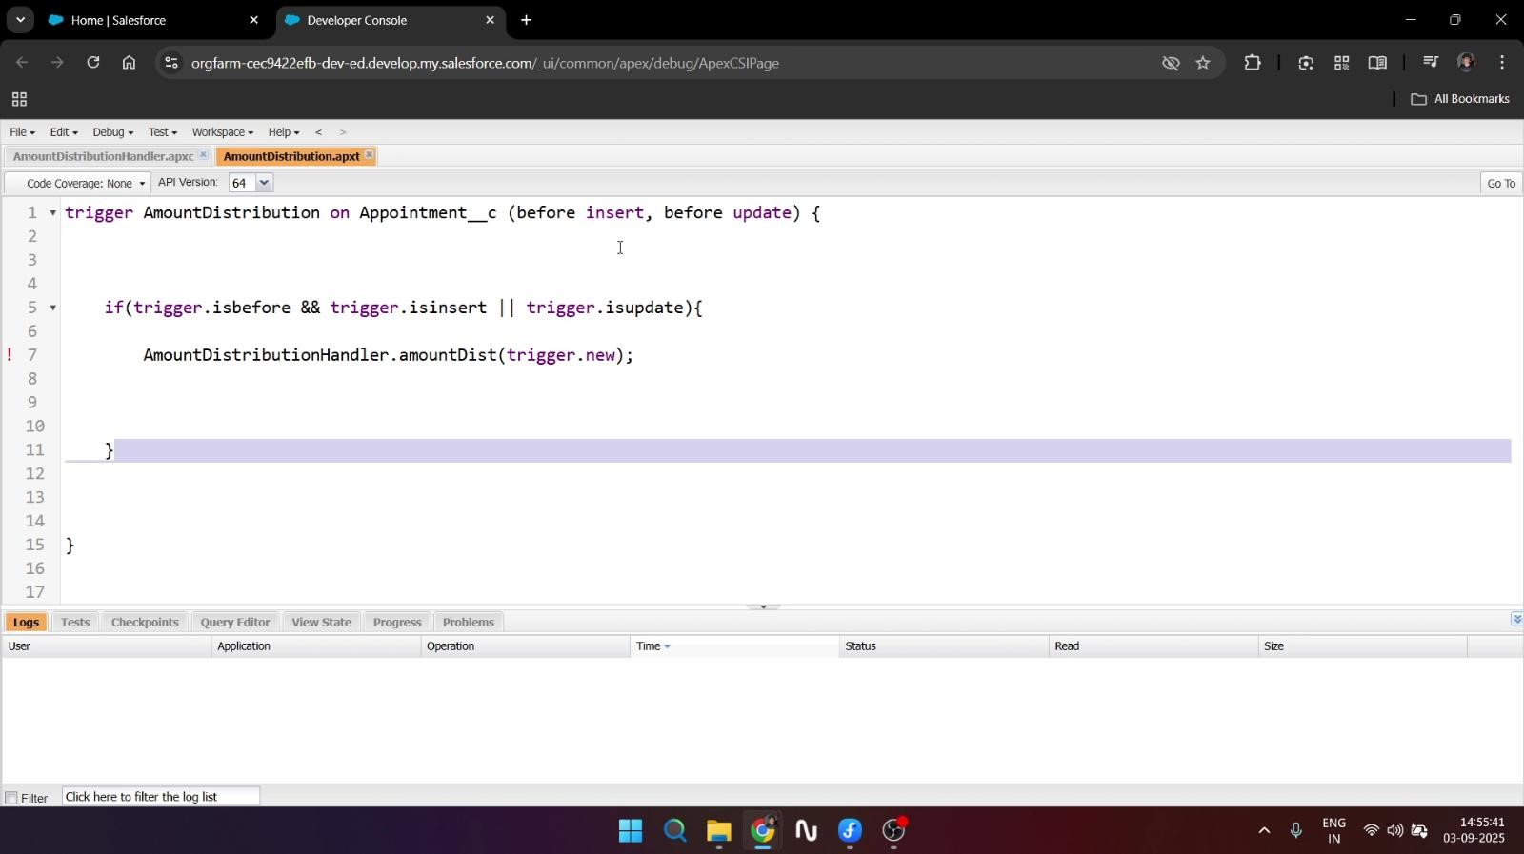

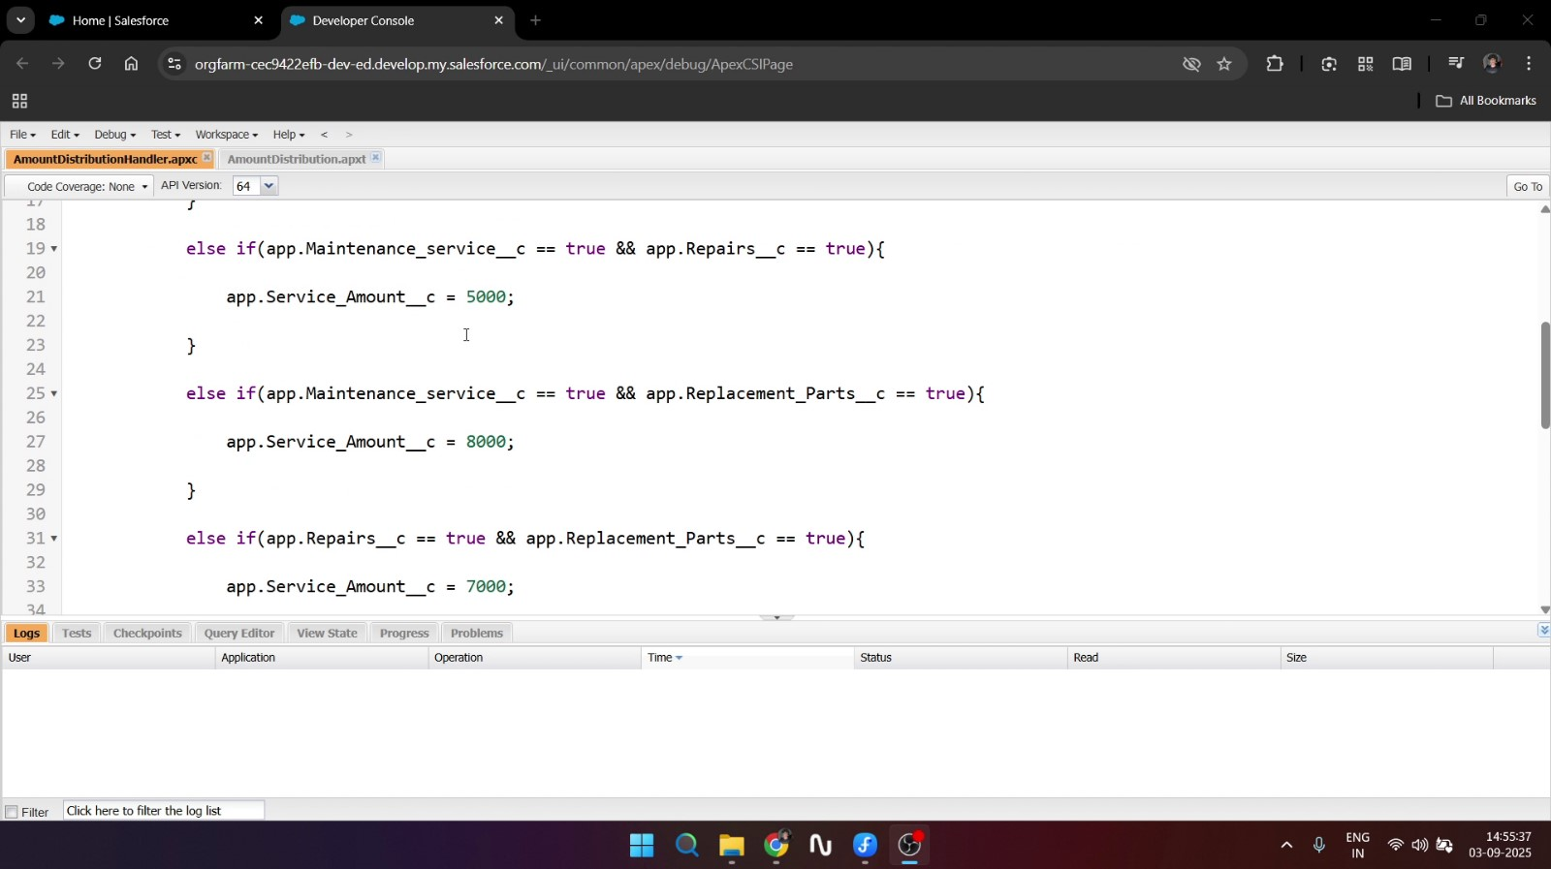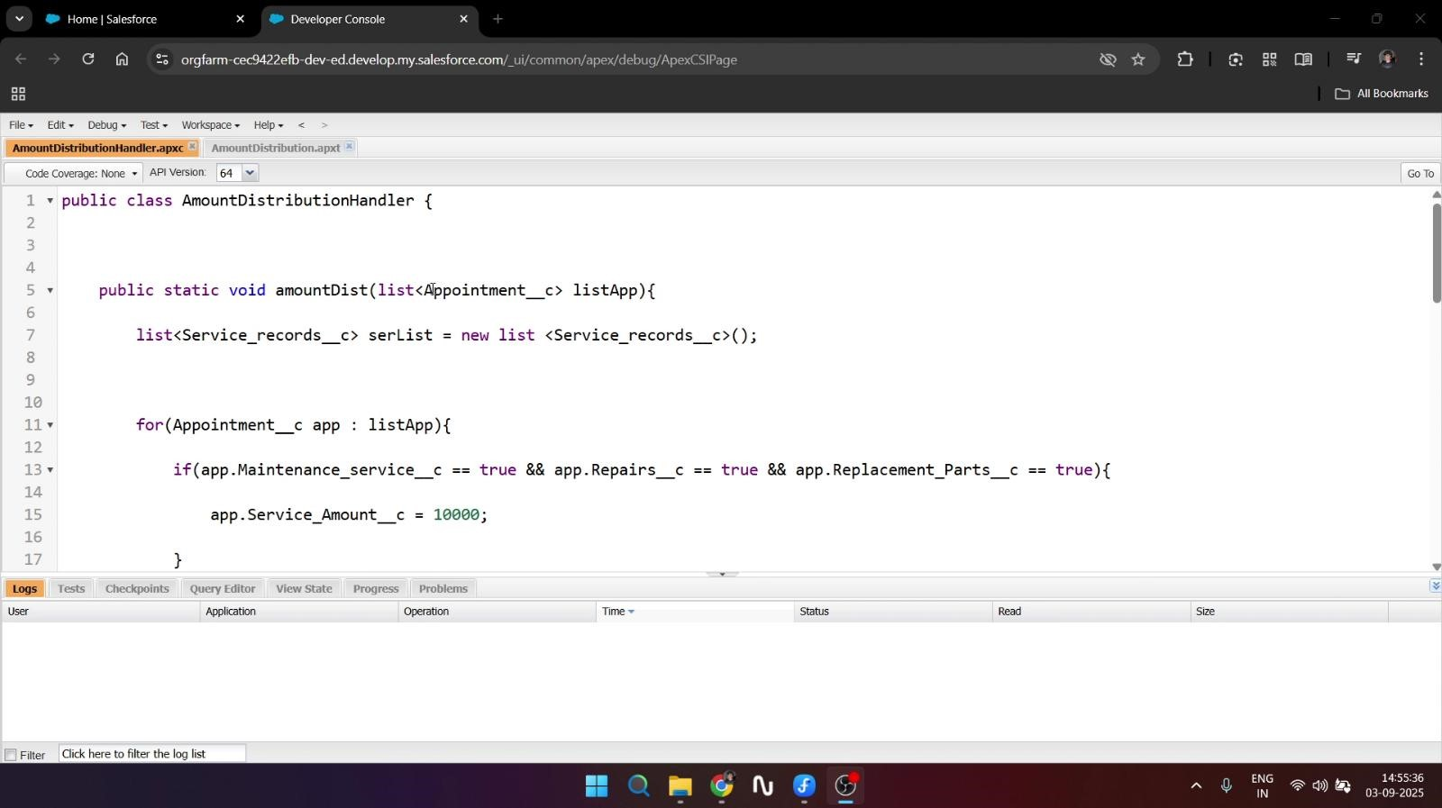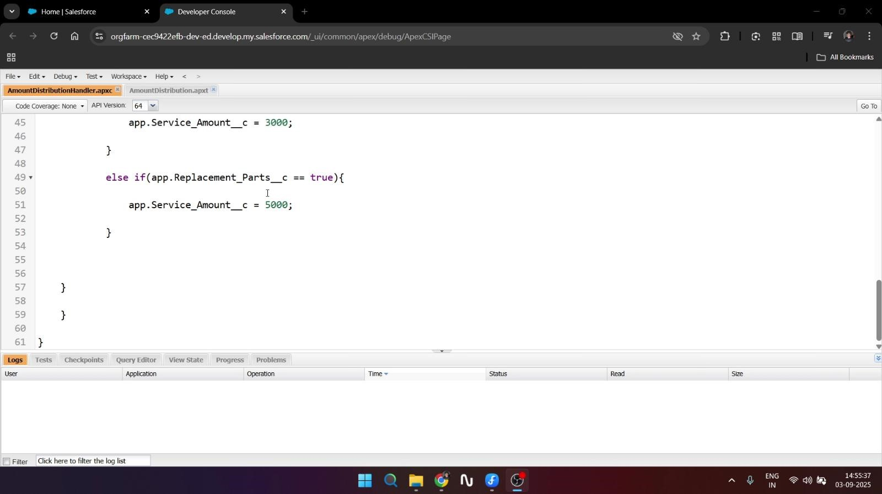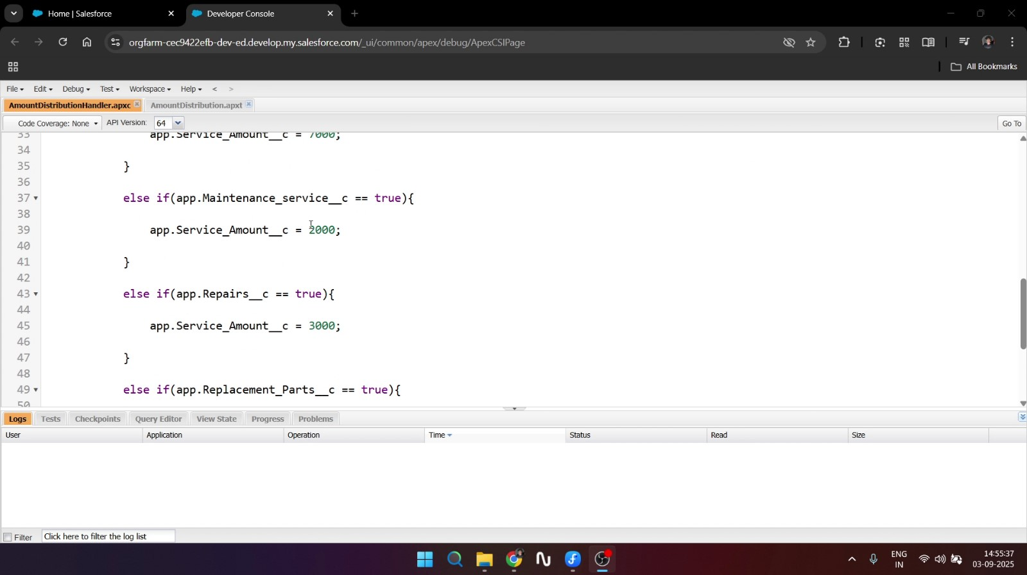

**Testing with some datas** (Reports, Dashboard, etc…)

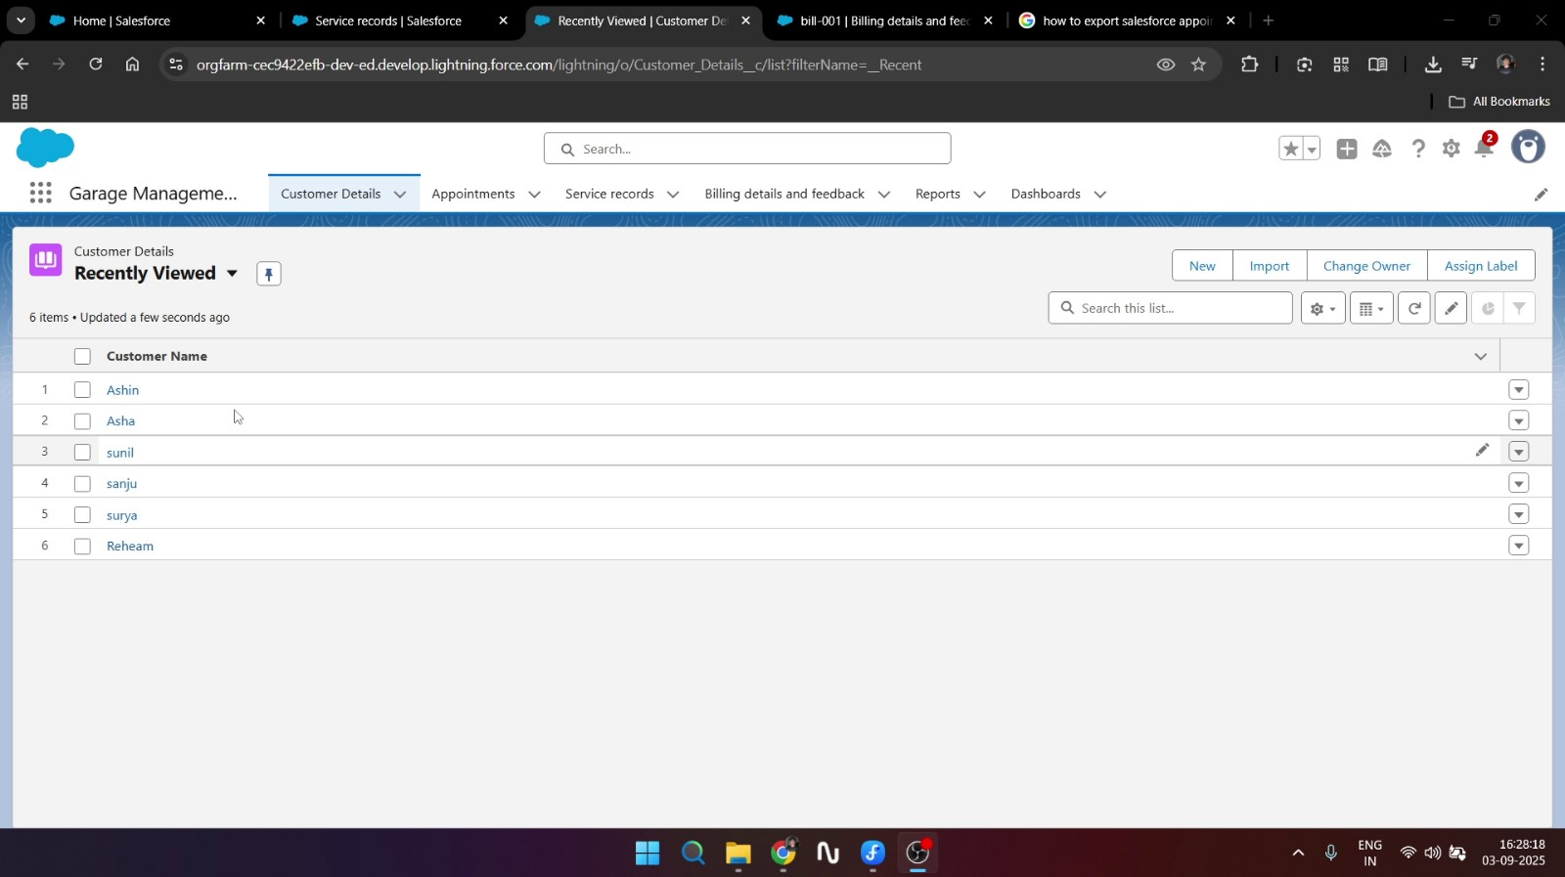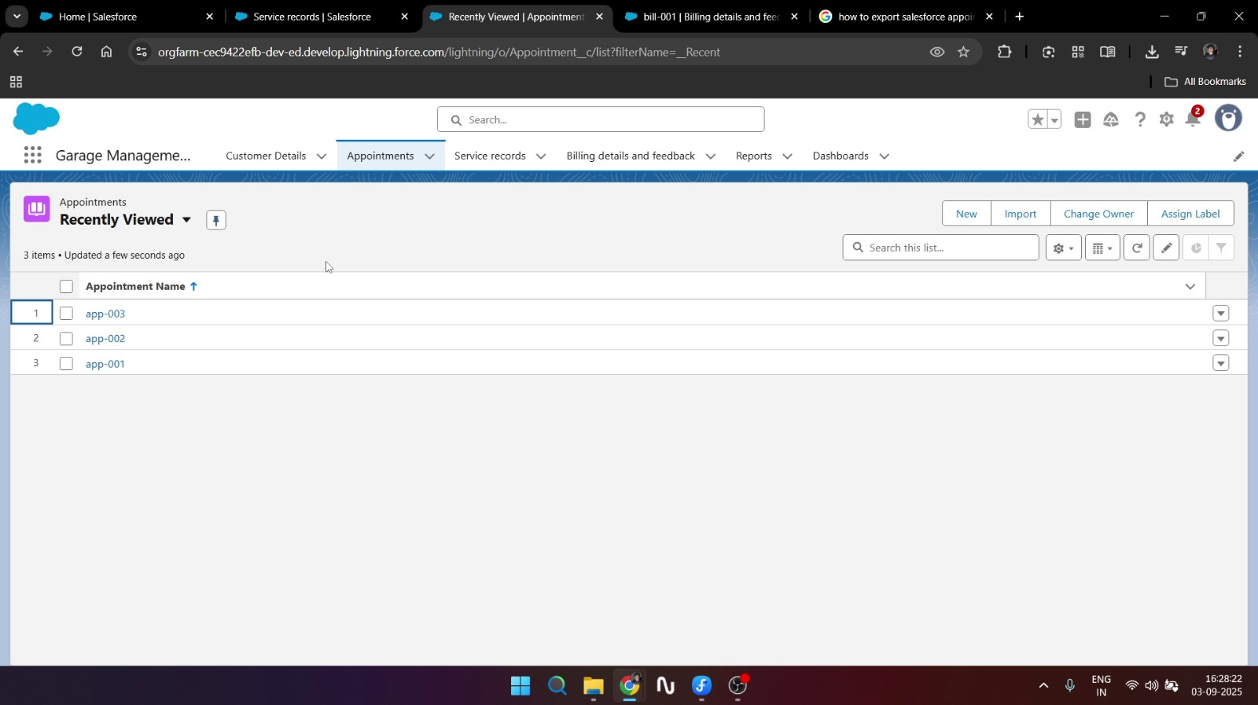

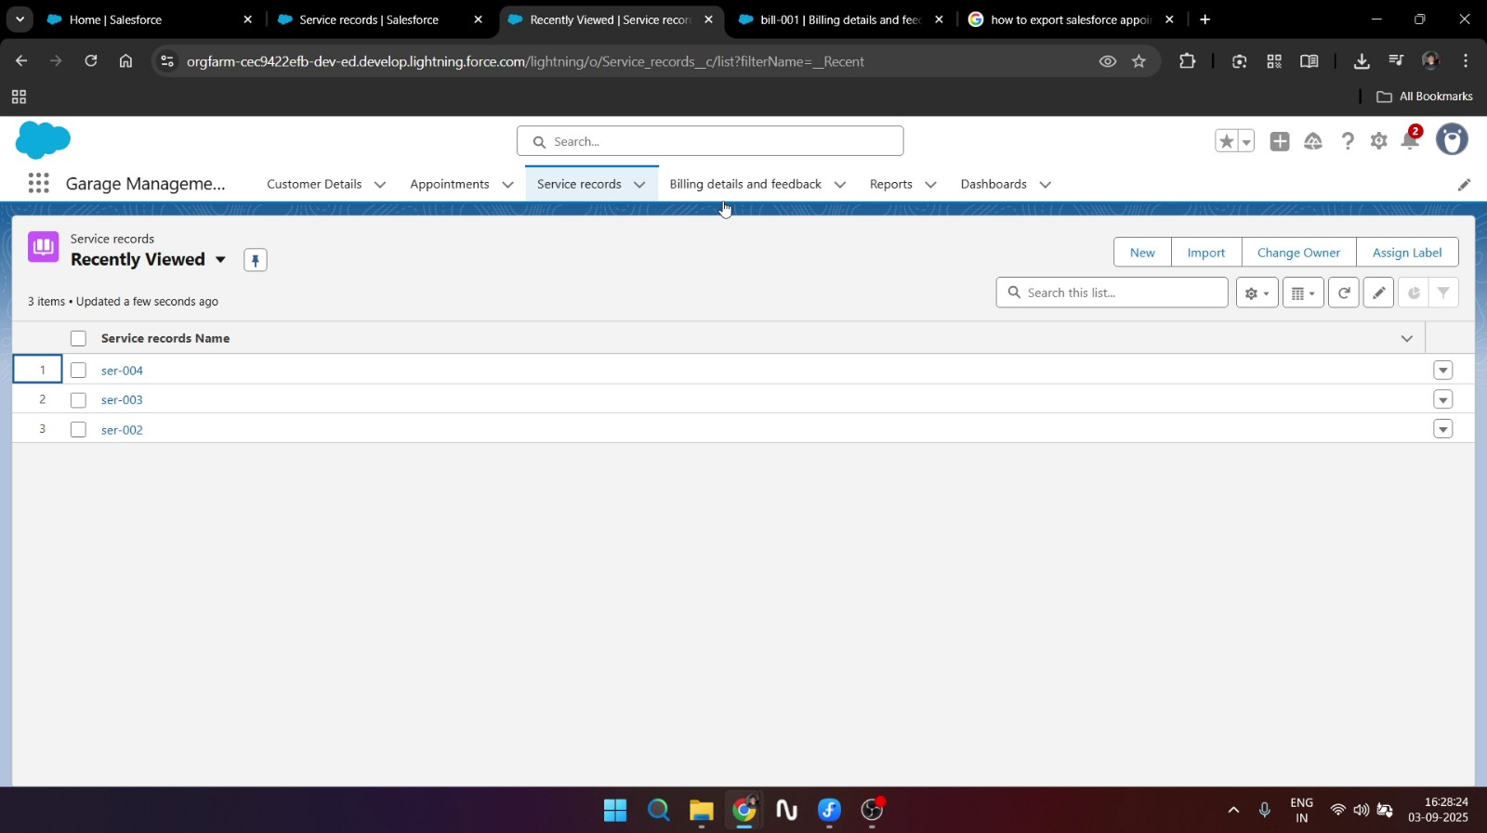

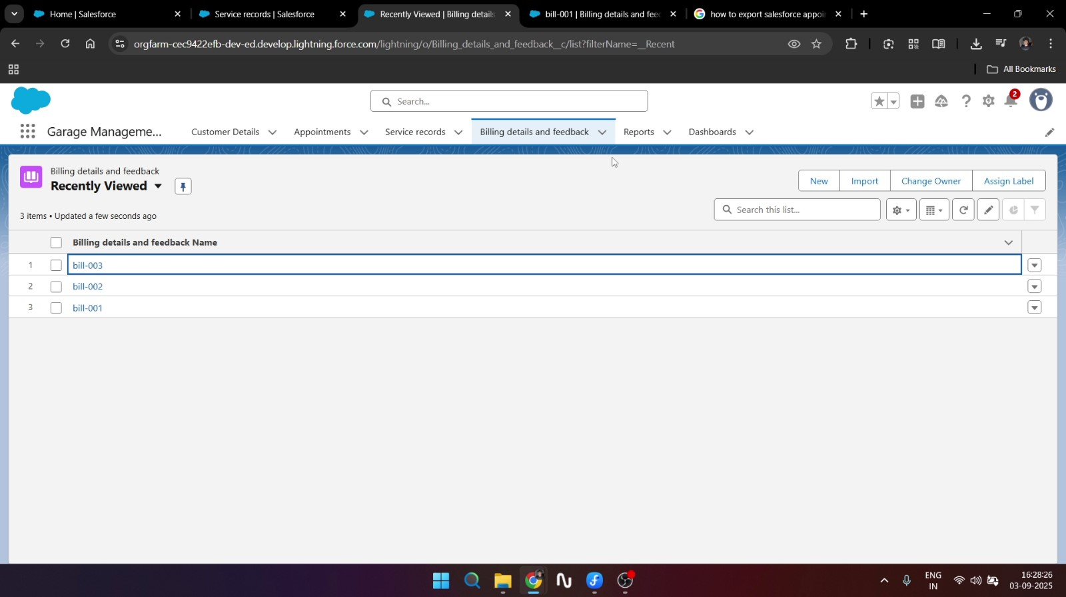

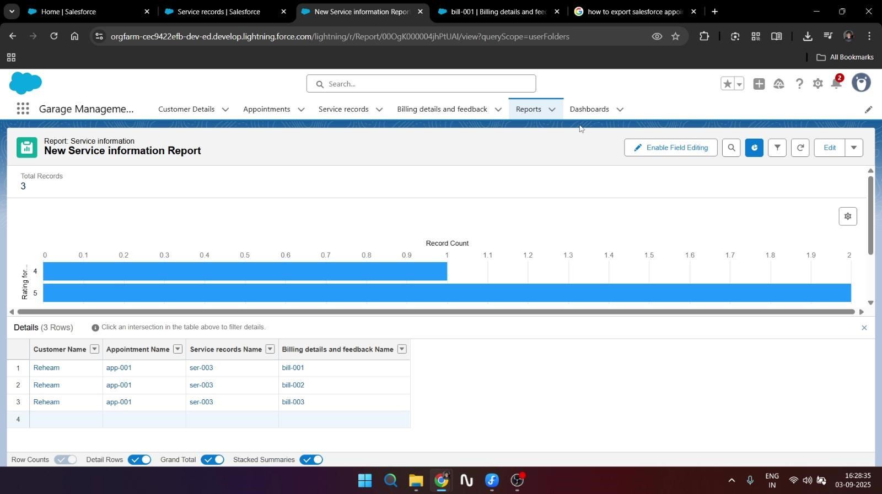

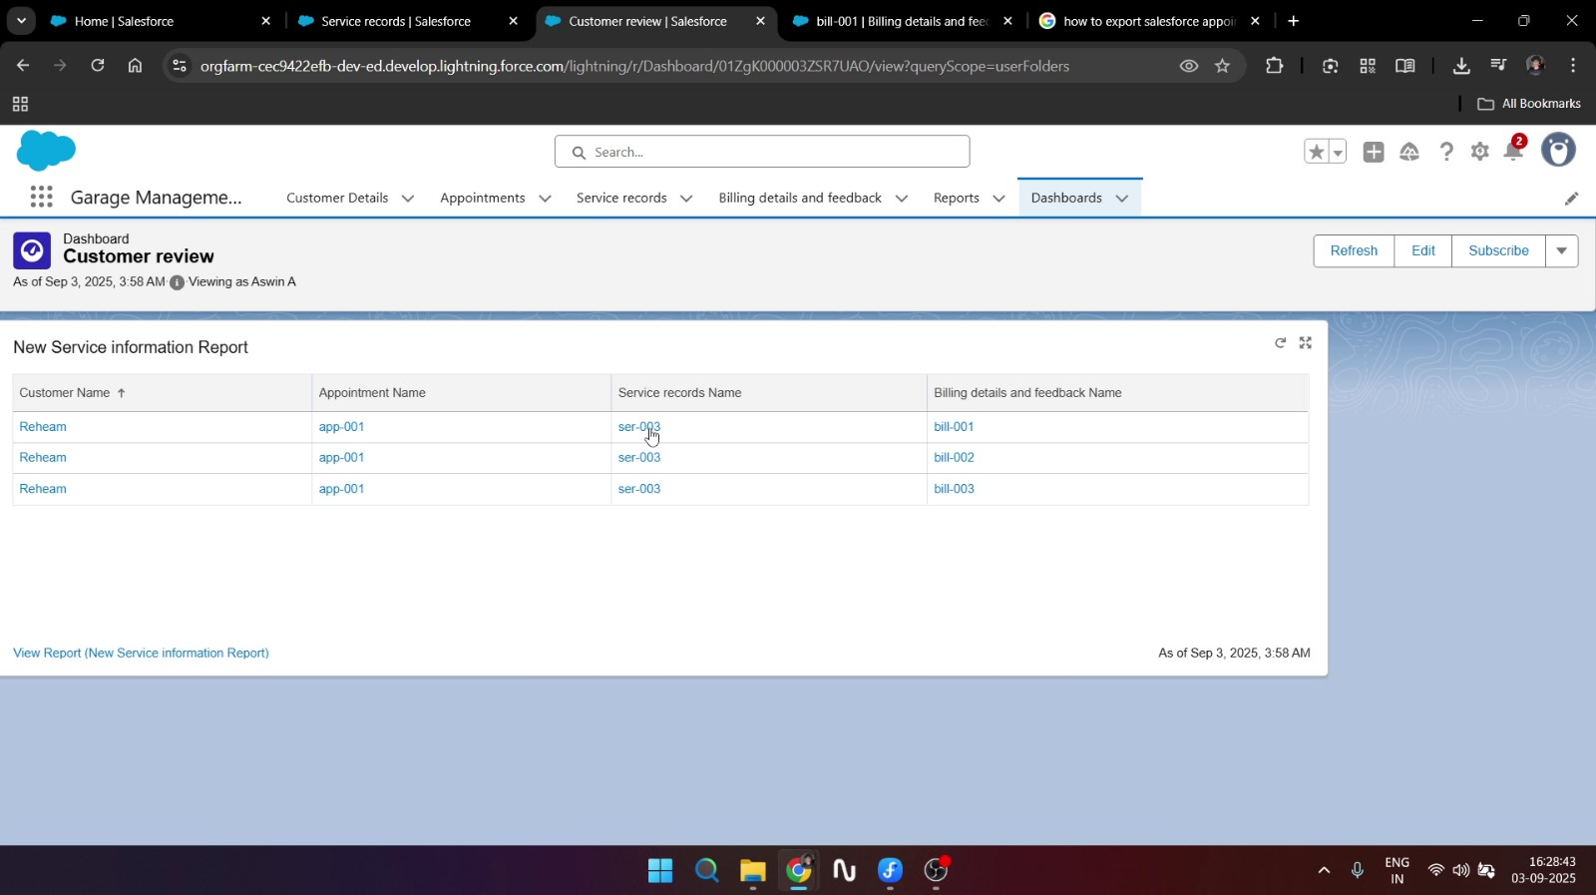

**What is a Validation Rule?**

In Salesforce, **Validation Rules** are used to ensure the accuracy and consistency of data entered into records before they are saved. A validation rule consists of a formula that evaluates the data entered, an error message that is displayed if the rule is violated, and the location where the error appears (either near a specific field or at the top of the page). These rules can be applied to both standard objects such as Account, Contact, and Opportunity, as well as custom objects.

**For example**, a validation rule can prevent users from entering a close date earlier than today on an Opportunity, restrict discounts to a maximum of 30%, ensure that phone numbers contain exactly 10 digits, or confirm that a rating field has values only between 1 and 5. By implementing validation rules, Salesforce administrators can prevent incorrect data from being saved, improve data quality, and maintain reliable business processes across the system.

**What is Approval processes?**

In Salesforce, an **Approval Process** is an automated workflow that defines how a record (such as a Leave Request, Expense Report, Opportunity Discount, or any custom object record) is reviewed and approved within an organization. It ensures that important records go through the proper chain of approval before being finalized. An approval process specifies the steps a record must follow, the criteria for entry, the approvers, and the actions to take when a record is approved, rejected, recalled, or reassigned.

* Entry Criteria: Conditions that decide when a record should enter the approval process (e.g., Discount > 30%).
* Approval Steps: Define who approves the record at each stage (user, role, or queue).
* Initial Submission Actions: Actions triggered when a record is submitted (e.g., lock record, send email notification).
* Approval/Rejection Actions: Define what happens when a record is approved or rejected (e.g., update field values, send email, create tasks).
* Final Actions: Executed after the process is completed (either approved or rejected).

**For example**, in a Garage Management System, an approval process could be set up for high-value bills where any invoice above ₹50,000 requires manager approval before being finalized. Similarly, a service report involving warranty claims could go through an approval process by the warranty department before the repair is carried out.

By using approval processes, Salesforce helps businesses maintain control, enforce compliance, and ensure that only authorized records are finalized or acted upon.

**What is Automation flows?**

In Salesforce, Automation Flows (built using Flow Builder) are powerful tools that allow you to automate complex business processes without writing code. A Flow is an application inside Salesforce that collects data, performs logic, updates records, sends notifications, or takes other actions automatically based on defined conditions. They are part of Salesforce’s Flow Automation Suite, which also includes Workflow Rules and Process Builder, but Flows are the most advanced and flexible option.

A Flow consists of elements (like Create, Update, Delete, Screen, Assignment), resources (variables, formulas, constants), and connectors (define the path between elements). Admins can design flows through a drag-and-drop interface. Flows can run in the background automatically or be triggered by user interactions.

**Benefits**

* Reduces manual effort and errors.
* Increases process efficiency and consistency.
* Improves customer experience through automation (like instant confirmations, reminders, and updates).
* Can replace older automation tools (Workflow Rules, Process Builder)

**Future Enhancements**

In the future, the Garage Management System can be improved by adding more advanced features. A chatbot can be integrated to help customers book appointments or get quick answers to their questions. Artificial Intelligence (AI) can be used to suggest services based on a vehicle’s history. A mobile app can be developed so customers can easily access services from their phones. Online payment options can also be added for faster and easier billing. These enhancements will make the system more user-friendly, efficient, and modern.

## Conclusion

The **Garage Management System** is designed to make garage operations simple, efficient, and well-organized. It brings all important tasks such as managing customer details, scheduling appointments, preparing service reports, generating bills, collecting feedback, and creating reports into a single system. This reduces the need for manual paperwork and helps the staff save time while avoiding mistakes.

By using this system, garages can provide faster and more accurate services to their customers, which improves customer satisfaction and trust. Managers can also get clear insights from reports and dashboards, which support better decision-making and business growth.

Overall, this project highlights how technology can transform the way garages work by making processes easier, quicker, and more reliable. In the future, the system can be enhanced with features like mobile applications, chatbots, and AI-based suggestions to make it even more powerful and customer-friendly.

**DEMO VIDEO : https://drive.google.com/file/d/19sl-jZRR7ZEnaxqxarFzez2eyKR8uhFE/view?usp=drivesdk**